**Boosting algorithm**

A **Boosting algorithm** is a machine learning technique designed to improve the accuracy of predictive models by combining the outputs of multiple "weak learners" to form a strong learner. Weak learners are models that perform slightly better than random guessing (e.g., a shallow decision tree). By iteratively training these weak learners and correcting their mistakes, boosting algorithms build a powerful ensemble model capable of making accurate predictions.

Boosting is powerful because it combines the simplicity of weak learners with iterative error correction, resulting in highly accurate predictive models.

***Explanation of Boosting Algorithm***

A **boosting algorithm** is like having a group of friends help you solve a tough problem. Some friends are good at certain parts of the problem, while others are better at different parts. Instead of asking just one friend for help, you ask all of them, step by step, to come up with the best solution together.

Here’s how it works in simple terms:

1. **Start with a weak helper**: At first, you ask one friend to try solving the problem, but they only do okay. Their solution isn’t perfect, but they give you a starting point.
2. **Focus on the tricky parts**: Next, you figure out where the first friend made mistakes, and then ask another friend to focus on fixing those tricky parts.
3. **Keep improving**: You keep adding more friends to the team, each one focusing on fixing the mistakes of the last, until the group has solved the problem much better than any one friend could alone.
4. **Combine everyone’s work**: At the end, you combine the efforts of all your friends to come up with the final answer. Each friend's contribution is weighed based on how helpful they were.

In machine learning, boosting works similarly. It combines the predictions of many simple models (like decision trees) to create a more accurate model. By focusing on the errors of previous models, boosting "boosts" the overall performance, leading to better results.

***Types of Boosting algorithm***

1. **Gradient Boosting –** Uses gradient descent to minimize errors by training on the residuals of previous models.
2. **Light Gradient Boosting –** A boosting algorithm optimized for speed and efficiency, especially with large datasets.
3. **Extreme Gradient Boosting –** An efficient and scalable implementation of gradient boosting with additional optimizations.
4. **Adaptive Gradient Boosting –** Adjusts weights of training samples based on errors, focusing on hard-to-classify examples.
5. **CatBoost** – Specializes in handling categorical data and provides fast training.

***Working Principle of Boosting Algorithm:***

1. **Train the first model (weak learner)**: The algorithm starts by training a simple model on the data. This model makes predictions but has errors (misclassifications or residuals).
2. **Focus on errors**: The algorithm identifies the mistakes made by the first model and gives these errors more importance by adjusting the weights of the training examples. Misclassified points are given higher weights so that the next model focuses more on them.
3. **Train additional models**: Another weak learner is trained, but this time it emphasizes the harder examples from the first model. This process repeats, with each new model correcting the errors of its predecessor.
4. **Combine the models**: All the weak learners are combined to form the final strong model. The contribution of each model is weighted based on its performance.

***Process Flow Diagram of Boosting Algorithm:***

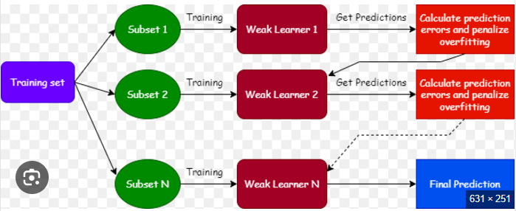

***Applications of Boosting Algorithm:***

• Fraud detection

• Customer churn prediction

• Ranking problems (e.g., search engines)

• Medical diagnosis

• Image recognition

**Light Gradient Boosting:**

**Light Gradient Boosting** is a fast, efficient, and scalable implementation of gradient boosting, specifically designed for high-performance and large-scale machine learning tasks. It was developed by Microsoft and has become popular due to its efficiency and ease of use.

**Light Gradient Boosting** is based on **gradient boosting**, where multiple weak learners (typically decision trees) are combined sequentially to improve prediction accuracy. Each new tree tries to correct the errors of the previous ones.

***Process Flow Diagram of Light Gradient Boosting:***

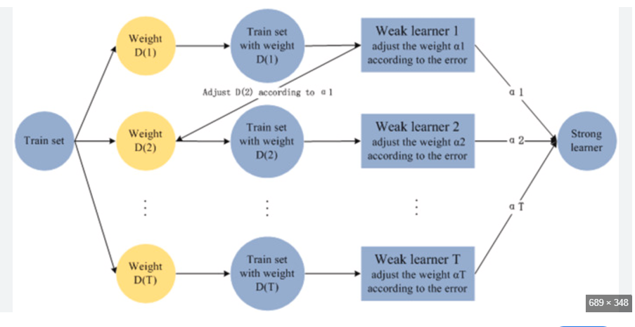

***Working Principles of Light Gradient Boosting:***

LightGBM is a gradient boosting ensemble method that is used by the [Train Using AutoML](https://pro.arcgis.com/en/pro-app/3.4/tool-reference/geoai/train-using-automl.htm) tool and is based on decision trees. As with other decision tree-based methods, LightGBM can be used for both classification and regression. LightGBM is optimized for high performance with distributed systems.

LightGBM creates decision trees that grow leaf wise, which means that given a condition, only a single leaf is split, depending on the gain. Leaf-wise trees can sometimes overfit especially with smaller datasets. Limiting the tree depth can help to avoid overfitting.

LightGBM uses a histogram-based method in which data is bucketed into bins using a histogram of the distribution. The bins, instead of each data point, are used to iterate, calculate the gain, and split the data. This method can be optimized for a sparse dataset as well. Another characteristic of LightGBM is exclusive feature bundling in which the algorithm combines exclusive features to reduce dimensionality, making it faster and more efficient.

Gradient-based One Side Sampling (GOSS) is used for sampling the dataset in LightGBM. GOSS weights data points with larger gradients higher while calculating the gain. In this method, instances that have not been used well for training contribute more. Data points with smaller gradients are randomly removed and some are retained to maintain accuracy. This method is typically better than random sampling given the same sampling rate.

1. **Gradient Boosting Framework**:
   * Like other gradient boosting algorithms (e.g., XGBoost), LightGBM builds an ensemble of decision trees sequentially.
   * Each tree is trained to correct the errors of its predecessor by minimizing a specified loss function (e.g., mean squared error for regression or log loss for classification).
   * The algorithm uses **gradient descent** to optimize the predictions at each stage, ensuring a steady reduction in the loss function.
2. **Leaf-wise Growth Strategy**:
   * Unlike traditional boosting methods that grow trees level-by-level, LightGBM uses a **leaf-wise** tree growth strategy.
   * At each step, it splits the leaf with the maximum loss reduction.
   * This approach reduces the overall loss more efficiently, resulting in deeper and potentially more complex trees.
   * However, to avoid overfitting, the maximum depth of the tree or other regularization constraints can be specified.
3. **Histogram-based Feature Binning**:
   * LightGBM converts continuous features into discrete bins using a histogram-based technique.
   * Instead of evaluating all possible split points, it evaluates only a limited number of bins, significantly reducing computational cost and memory usage.
4. **Exclusive Feature Bundling (EFB)**:
   * LightGBM reduces feature dimensionality by bundling mutually exclusive features (features that rarely take non-zero values simultaneously).
   * This optimization is particularly useful for sparse datasets, improving computational efficiency.
5. **Gradient-based One-Side Sampling (GOSS)**:
   * In datasets with many rows, LightGBM reduces the number of data points used for training by sampling based on the gradients.
   * Instances with large gradients (indicating higher loss) are retained, while those with small gradients are subsampled.
   * This ensures the model focuses on hard-to-learn examples while maintaining computational efficiency.
6. **Regularization**:
   * To prevent overfitting, LightGBM incorporates techniques like:
     + Limiting the maximum depth of trees.
     + Applying L1/L2 regularization on the leaf weights.
     + Using early stopping to terminate training when further iterations don't improve validation metrics.

***Advantages of Light Gradient Boosting:***

• **Speed**: LightGBM is faster than many other implementations, such as XGBoost, due to its optimization techniques.

• **Memory Efficiency**: It uses less memory compared to alternatives.

• **Scalability**: It handles large datasets effectively.

• **Accuracy**: It often achieves high accuracy, especially on structured/tabular datasets.

***Disadvantages of Light Gradient Boosting:***

1. **Risk of Overfitting**: Leaf-wise growth can lead to overfitting, especially on small datasets.
2. **Sensitive to Hyperparameters**: Requires careful tuning to achieve optimal performance.
3. **Not Ideal for Small Datasets**: Performs poorly on small datasets compared to simpler models.
4. **Complexity in Interpretation**: Difficult to interpret results due to the complexity of the model.
5. **Potential for Overly Deep Trees**: Leaf-wise growth can produce excessively deep trees, increasing computation and memory usage.
6. **Challenges with Highly Imbalanced Data**: Can struggle without proper handling of class imbalances.
7. **Sensitivity to Noise and Outliers**: Aggressive splitting strategy makes it vulnerable to noisy data.
8. **Limited GPU Support**: Some features are not compatible with GPU training.
9. **Feature Importance Misrepresentation**: May provide misleading feature importance scores if hyperparameters are not tuned appropriately.
10. **Sparse Data Limitations**: Performance can vary with excessively sparse or missing data.

***Applications of Light Gradient Boosting:***

* **Classification**: Predicting discrete outcomes, e.g., spam detection, fraud detection.
* **Regression**: Predicting continuous values, e.g., stock prices, weather forecasting.
* **Ranking Problems**: For instance, in search engines or recommendation systems.
* **Time-Series Analysis**: When combined with techniques for handling sequential data.

**Extreme Gradient Boosting:**

**It is** a highly efficient and flexible implementation of the gradient boosting framework. It is designed to optimize speed, performance, and resource efficiency for machine learning tasks, especially on structured/tabular data. XGBoost has gained widespread popularity due to its ability to deliver high predictive accuracy and handle various data scenarios effectively.

***Process Flow Diagram of Extreme Gradient Boosting:***

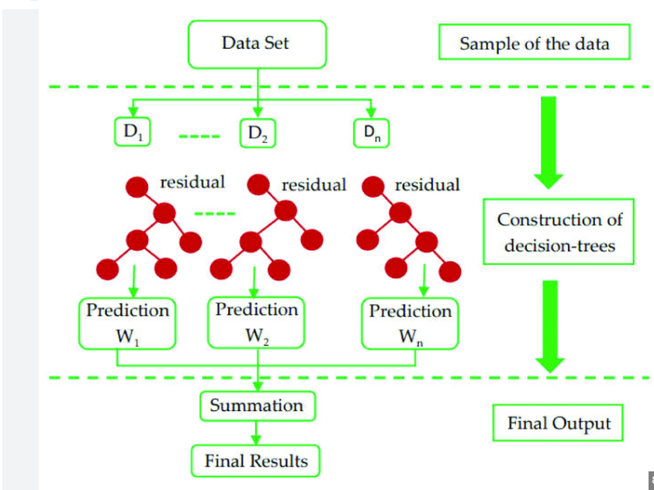

***How Extreme Gradient Boosting Works:***

XGBoost is a supervised machine learning method for classification and regression and is used by the [Train Using AutoML](https://pro.arcgis.com/en/pro-app/3.3/tool-reference/geoai/train-using-automl.htm) tool. XGBoost is short for extreme gradient boosting. This method is based on decision trees and improves on other methods such as random forest and gradient boost. It works well with large, complicated datasets by using various optimization methods.

To fit a training dataset using XGBoost, an initial prediction is made. Residuals are computed based on the predicted value and the observed values. A decision tree is created with the residuals using a similarity score for residuals. The similarity of the data in a leaf is calculated, as well as the gain in similarity in the subsequent split. The gains are compared to determine a feature and a threshold for a node. The output value for each leaf is also calculated using the residuals. For classification, the values are typically calculated using the log of odds and probabilities. The output of the tree becomes the new residual for the dataset, which is used to construct another tree. This process is repeated until the residuals stop reducing or for a specified number of times. Each subsequent tree learns from the previous trees and is not assigned equal weight, unlike how [Random Forest](https://pro.arcgis.com/en/pro-app/3.3/tool-reference/geoai/how-random-trees-classification-and-regression-works.htm) works.

To use this model for prediction, the output from each tree multiplied by a learning rate is added to the initial prediction to arrive at a final value or classification.

XGBoost uses the following parameters and methods to optimize the algorithm and provide better results and performance:

Regularization—A Regularization parameter (lambda) is used while calculating the similarity scores to reduce the sensitivity to individual data and avoid overfitting.

Pruning—A Tree Complexity Parameter (gamma) is selected to compare the gains. The branch where the gain is smaller than the gamma value is removed. This prevents overfitting by trimming unnecessary branches and reducing the depth of the trees.

Weighted quantile sketch—Instead of testing every possible value as the threshold for splitting the data, only weighted quantiles are used. The selection of quantiles is done using a sketch algorithm, which estimates a distribution on multiple systems over a network.

Parallel Learning—This method divides the data into blocks that can be used in parallel to create the trees or for other computations.

Sparsity-aware split finding—XGBoost handles sparsity in data by trying both directions in a split and finding a default direction by calculating the gain.

Cache-aware Access—This method uses the cache memory of the system to calculate the similarity scores and output values. The cache memory is a faster access memory compared to the main memory and improves the overall performance of the model.

Blocks for Out-of-core Computation—This method works with large datasets that cannot fit in the cache or the main memory and that must be kept in hard drives. The dataset is divided into blocks and compressed. Uncompressing the data in the main memory is faster than reading from the hard drive. Another technique called sharding is used when the data must be kept on multiple hard drives.

***Advantages of extreme Gradient Boosting:***

1. **High Predictive Accuracy**: Consistently achieves top performance on a wide range of machine learning tasks.
2. **Fast and Efficient**: Uses parallel processing and optimized algorithms for faster training and prediction.
3. **Robustness to Missing Data**: Handles missing values natively without requiring imputation.
4. **Regularization**: Includes L1 (Lasso) and L2 (Ridge) regularization to prevent overfitting.
5. **Custom Loss Functions**: Allows defining custom objectives for flexibility in solving unique problems.
6. **Feature Importance Metrics**: Provides detailed insights into feature contributions for better interpretability.
7. **Sparsity Awareness**: Efficiently handles sparse and high-dimensional data.
8. **Scalability**: Works well with large datasets and complex models.
9. **Cross-Platform Compatibility**: Available in multiple programming languages like Python, R, C++, Java, and Julia.
10. **Versatility**: Supports regression, classification, ranking, and even survival analysis tasks.

***Disadvantages of extreme Gradient Boosting:***

1. **Computationally Intensive**: Training XGBoost can be resource-intensive, requiring significant CPU/GPU power and memory for large datasets.
2. **Slower Compared to LightGBM**: XGBoost’s level-wise tree growth is slower than LightGBM’s leaf-wise growth for large datasets.
3. **Hyperparameter Tuning**: Requires careful tuning of multiple hyperparameters (e.g., learning rate, max depth, regularization) for optimal performance.
4. **Risk of Overfitting**: Prone to overfitting if trees are too deep or if regularization parameters are not set properly.
5. **Complexity in Interpretation**: Like most boosting algorithms, XGBoost is a "black-box" model, making it harder to interpret compared to simpler models like linear regression.
6. **Handling Categorical Features**: Lacks native support for categorical variables, requiring preprocessing (e.g., one-hot encoding).
7. **Limited Scalability on Small Datasets**: May not perform as well on small datasets due to its computational overhead.
8. **Sensitivity to Noise**: Can be sensitive to noisy data, leading to suboptimal splits and reduced performance.

***Applications of Extreme Gradient Boosting*:** Extreme Gradient Boosting (XGBoost) is a powerful machine learning algorithm used in various real-world applications due to its speed, accuracy, and flexibility. Here are some key applications:

1. **Finance**
   * **Credit scoring**: Predicting whether a borrower will default on a loan.
   * **Fraud detection**: Identifying fraudulent activities in transactions or accounts.
2. **Healthcare**
   * **Disease diagnosis**: Predicting the likelihood of diseases based on patient data.
   * **Medical image analysis**: Classifying or detecting abnormalities in medical images.
3. **Retail & E-commerce**
   * **Customer churn prediction**: Determining which customers are likely to leave a service or brand.
   * **Sales forecasting**: Predicting future sales based on historical data.
   * **Recommendation systems**: Suggesting products to users based on past behaviors.
4. **Marketing & Advertising**
   * **Targeted marketing**: Predicting which customers are most likely to respond to a campaign.
   * **Click-through rate prediction**: Estimating the likelihood of a user clicking on an online ad.
5. **Energy & Utilities**
   * **Energy consumption forecasting**: Predicting the energy demand in a region.
   * **Smart grid management**: Optimizing energy distribution and usage.
6. **Transportation**
   * **Traffic prediction**: Forecasting traffic patterns for route optimization.
   * **Vehicle route planning**: Predicting the best routes for delivery services.
7. **Natural Language Processing (NLP)**
   * **Sentiment analysis**: Classifying text data as positive, negative, or neutral.
   * **Text classification**: Categorizing documents, emails, or other textual data.
8. **Manufacturing**
   * **Predictive maintenance**: Predicting when machinery or equipment will fail, reducing downtime.
   * **Supply chain optimization**: Optimizing inventory levels and supply chain processes.
9. **Gaming & Sports**
   * **Game outcome prediction**: Predicting the outcome of sports events or video games.
   * **Player performance analysis**: Evaluating the performance of players based on various metrics.
10. **Climate Science**

* **Weather prediction**: Forecasting temperature, rainfall, and other weather parameters.
* **Environmental monitoring**: Predicting pollution levels or environmental changes.

**Adaptive Boosting**

**Adaptive Boosting** (AdaBoost) is an ensemble learning technique that combines multiple weak learners to create a strong predictive model. The key idea behind AdaBoost is to iteratively improve the model by focusing more on the errors (misclassified instances) made by previous models, thereby "boosting" the overall performance.

**Process Flow Diagram of Adaptive Gradient Boosting:**

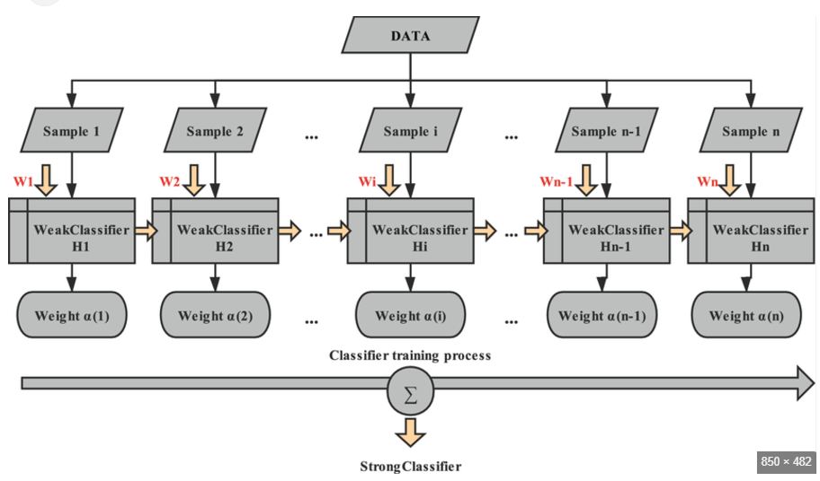

**How AdaBoost Works:** AdaBoost (Adaptive Boosting) is an ensemble learning algorithm that combines multiple weak classifiers to create a strong classifier. Here's a brief overview of how it works:

1. **Initialize Weights**: Assign equal weights to all training examples initially.
2. **Train Weak Learners**: Iteratively train weak classifiers (e.g., decision stumps) on the weighted dataset. At each iteration:
   * The weak learner focuses on examples that are harder to classify (those with higher weights).
   * Calculate the classifier's error rate on the training set.
3. **Update Weights**: Increase the weights of misclassified examples and decrease the weights of correctly classified examples. This ensures the next weak learner focuses more on the difficult cases.
4. **Combine Weak Learners**: Assign a weight to each weak learner based on its accuracy, and combine them into a single strong classifier through a weighted vote.

The process continues for a fixed number of iterations or until the error rate is acceptably low. The final model is a weighted sum of the weak classifiers.

**Advantages of Adaptive Boosting**

1. **Better Accuracy**: AdaBoost combines many weak models (models that don’t perform well on their own) to create one strong model, improving its overall accuracy.
2. **Prevents Overfitting**: Unlike some models that memorize the data, AdaBoost avoids overfitting by focusing on the mistakes and improving on them, rather than memorizing the data.
3. **Works with Different Models**: AdaBoost can work with different types of simple models, though it often uses simple decision trees. This makes it flexible.
4. **Good with Imbalanced Data**: If one class is underrepresented in your data, AdaBoost can focus more on that class, helping it perform better with imbalanced datasets.
5. **Easy to Use**: AdaBoost doesn’t require much tuning of parameters, so it’s relatively easy to use. You only need to decide on the number of rounds and the learning rate.
6. **Fast and Simple**: AdaBoost is quick to train and easy to implement, especially when using simple models.
7. **Handles Some Noise**: AdaBoost can handle noisy data better than some other models, although it’s not perfect in very noisy situations.
8. **Easy to Understand**: Since AdaBoost uses simple models, it’s easier to understand how the final model works compared to more complex methods like deep learning.
9. **Strong Theory**: AdaBoost is based on solid mathematical theory, which helps ensure that it works well on new, unseen data.
10. **Improves Weak Models**: AdaBoost can turn weak models, which might not be good at classifying on their own, into powerful ones by focusing on their mistakes and improving over time.

**Disadvantages of Adaptive Boosting**

1. **Sensitive to Noisy Data**: AdaBoost can get confused by noisy or outlier data (incorrect or extreme data points). It might focus too much on these tricky points and make the model worse.
2. **Requires a Lot of Weak Models**: To get good results, AdaBoost usually needs many rounds of boosting (many weak models). This can make it slower to train, especially on large datasets.
3. **Not Good for Large Datasets**: AdaBoost can struggle with very large datasets, as it needs to iterate through the data multiple times, which can be computationally expensive.
4. **Prone to Overfitting with Too Many Rounds**: If you train AdaBoost for too many rounds, it might start overfitting to the data, meaning it gets too specific and won’t generalize well to new data.
5. **Weak Models Can Limit Performance**: If the weak models used (like decision stumps) are too simple or weak, AdaBoost might not be able to improve enough, limiting the final model’s performance.
6. **Not Good for Complex Problems**: AdaBoost may not perform as well on very complex problems, where simple models like decision trees can’t capture the needed patterns, even with boosting.

**Applications of AdaBoost:** AdaBoost is widely used in various applications due to its flexibility and effectiveness. Some key applications include:

* **Binary Classification**: It is commonly used for tasks like spam email detection or fraud detection.
* **Face Detection**: AdaBoost is often applied in computer vision for tasks like detecting faces in images.
* **Image Recognition**:
  + Used in **face detection** (e.g., Viola-Jones framework) by identifying facial features in images.
  + Applied in **object detection** for recognizing specific objects like vehicles or pedestrians.
* **Text Classification**:
  + Sentiment analysis and spam filtering.
  + Categorizing documents or emails into predefined classes.
* **Fraud Detection**:
  + Identifying fraudulent transactions in finance and e-commerce.
  + Detecting anomalies in user behavior.
* **Medical Diagnosis**:
  + Classifying diseases based on patient data, such as detecting tumors or diabetes risk.
  + Used in diagnostic tools for image-based analysis (e.g., radiology).
* **Customer Analytics**:
  + Predicting customer churn or purchasing behavior.
  + Segmenting customers for targeted marketing campaigns.
* **Credit Scoring**:
  + Evaluating the creditworthiness of applicants.
  + Detecting patterns in loan default risks.
* **Natural Language Processing (NLP)**:
  + Named entity recognition (NER).
  + Machine translation and language modeling.
* **Speech Processing**:
  + Enhancing speech recognition systems by classifying phonemes or word patterns.